Name: Swapnonil Banerjee
Domain: AI/ML
Assignment
Aim of the Assignment
The aim of this assignment is to create two tables in MySQL and perform conditional operations using WHERE clause with AND, OR, NOT, along with ORDER BY and LIKE operators.

Database Creation
Command:
CREATE DATABASE college_db;
Output:

Use Database Command
Command:
USE college_db;

Output:

Table Creation
Table 1: Students
Command:
CREATE TABLE Students(
student_id INT PRIMARY KEY,
name VARCHAR(50),
AGE INT,
city VARCHAR(50)
);
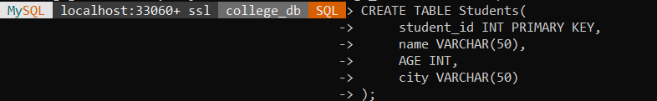

Output:

Table 2: Courses
Command:
CREATE TABLE Courses(
course_id INT PRIMARY KEY,
course_name VARCHAR(50),
duration INT
);
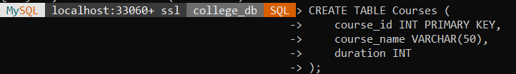

Output:

Inserting Data into Students Tables
Command:
INSERT INTO Students VALUES
(1, 'Amit', 21, 'Mumbai'),
(2, 'Neha', 22, 'Pune'),
(3, 'Rohit', 20, 'Delhi'),
(4, 'Nisha', 23, 'Mumbai');
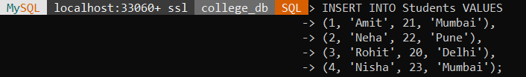

Output:
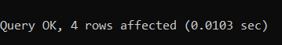

Insert Data into Courses Table
Command:
INSERT INTO Courses VALUES
(101, 'Data Science', 6),
(102, 'Web Development', 4),
(103, 'AI and ML', 8);
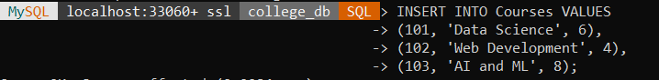


Output:

Display Students Table
Command:
SELECT * FROM Students;

Output:
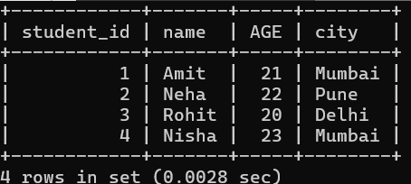

SQL Operations
WHERE Clause using AND
Command:
SELECT * FROM Students
WHERE AGE > 21 AND city = 'Mumbai';

Output:

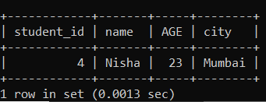

WHERE Clause using OR
Command:
SELECT * FROM Students
WHERE city = 'Mumbai' OR city = 'Pune';

Output:
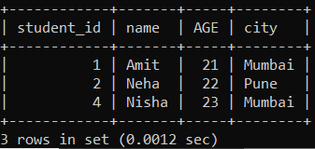

WHERE Clause using NOT
Command:
SELECT * FROM Students
WHERE NOT city = 'Delhi';

Output:
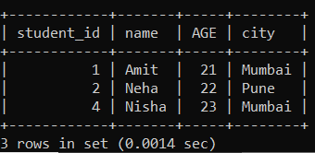

ORDER BY Clause
Command:
SELECT * FROM Students
ORDER BY AGE ASC;

Output:
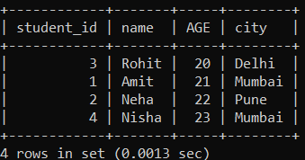

LIKE Operator
Command:
SELECT * FROM Students
WHERE name LIKE 'N%';

Output:
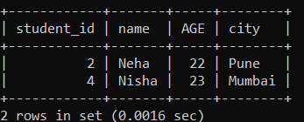

Conclusion
Thus, the MySQL database was successfully created and various conditional operations such as WHERE, AND, OR, NOT, ORDER BY, and LIKE were executed successfully using SQL queries.

